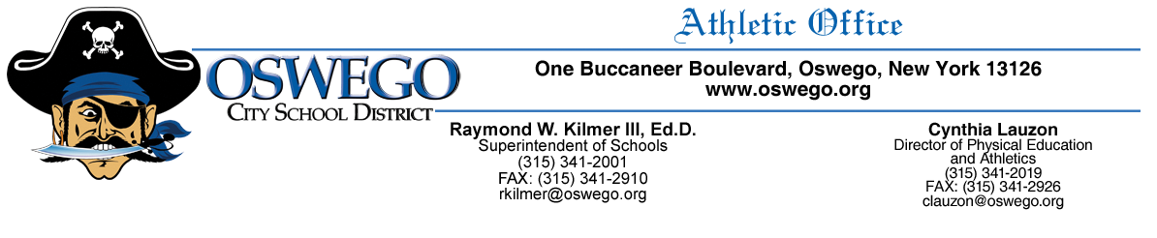
VOLUNTEER COACH APPLICATION

In agreement with the Oswego City School District Policy 3150 regarding school volunteers, the person filling out and signing this form understands their role as a volunteer coach for a school approved athletic team.

Name _______________________________________________________________________________

Address _____________________________________________________________________________

Email Phone

Athletic team interested to assist as a volunteer ______________________________________________

Season ________________________________ Year _________________________________________

School Approved Coach interested in helping ________________________________________________

College Attended ______________________________________________________________________

I played this sport in college. YES NO I played this sport in high school. YES NO

I have a child currently playing on this team. YES NO

My relationship with the coach I wish to volunteer with is ______________________________________

_____________________________________________________________________________________

I currently have training in CPR/AED and First Aid. YES NO

I would be interested in getting CPR/AED, First Aid training at my own cost. YES NO

I have been investigated for or convicted of an action/crime that would make me a risk to be working
with children. YES NO

I have read, acknowledged and received a copy of the Staff-Student Relations Fraternization Policy that was reviewed with me. YES NO

Why I am interested in working with this team/program _______________________________________

_____________________________________________________________________________________

I understand that if I do not uphold all policies of the Oswego City School District or work outside of the requirements set by the coach I am working with, I will be asked to stop my volunteer work with this team and will be held responsible for any liability I caused by said actions.

Print name _________________________________________ Date ______________________________

Applicant Signature _________________________________________________

Building Principal Signature _____________________________________________ Date ______________

Athletic Director Signature ______________________________________________ Date ______________

