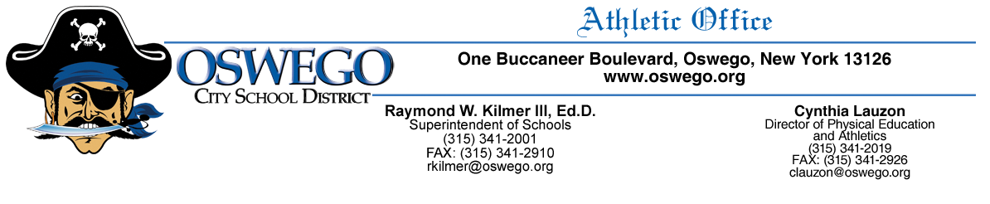
Volunteer Coach Requirements

- Fingerprint Clearance (through NYSED, call 877-472-6915 to set up appt., expense is individual’s responsibility)

- Completed Volunteer Coach Application (located in the athletics’ office)

- Valid First Aid (must be full first aid course approved by the NYSED, not a refresher)

- Valid CPR/AED (must be full CPR/AED course approved by the NYSED, not a refresher)

- Workshop- Child Abuse (mandated reporter)

- Workshop-Violence Intervention and Prevention

- Workshop- Dignity for All Students Act (see Section 3 website for class info.)

- Set up TEACH account (contact BOCES for more information 315-963-4286)

- Heads Up Concussion in Youth Sports Training www.cdc.gov/headsup/youthsports/training/index.html

All volunteer coaches must complete the above requirements in order for their name to be submitted on a board of education agenda for review. Start date of the volunteer coach will be effective the day following board approval. Volunteer coaching candidates may NOT serve in any coaching role until board approval. Angela Miller or I will contact you regarding volunteer coaching candidates’ status and effective start dates. Let me know if you have any questions and thank you for your dedication to our athletic teams.

Sincerely,

Cynthia Lauzon

