2nd Grade Supply List (CER) 2024-2025

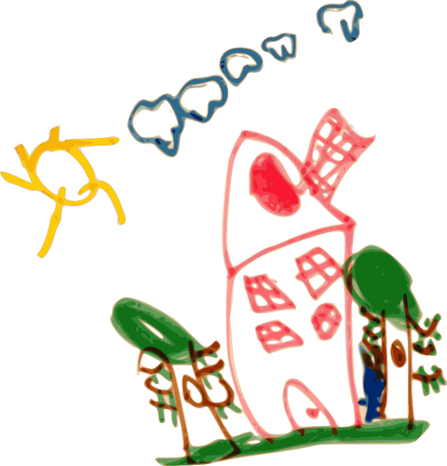

|  |
| --- |
| A **1 inch HARD COVERED** binder (the soft floppy covers don’t hold up as well)  WITH front pocket to slip a cover in it  (no bigger than 1 in. please! It won’t fit in their work bins) |
| plastic insert dividers with pockets (with 3 holes and tabs) |
| 2 solid colored plastic folders (1 red and 1 green) |
| pencil case/box to hold student pencils/crayons, etc. |
| scissors |
| #2 Pencils (sharpened if possible) |
| crayons |
| Dry erase markers |

EXTRA and OPTIONAL “NICE TO HAVE” ITEMS

|  |
| --- |
| markers |
| colored pencils |
| black sharpies |
| clipboard |