**CER 3rd Grade Supply List 2024-2025**

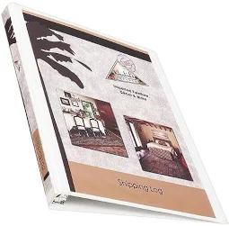

* A **½ inch binder** that is clear plastic bound so you can slip a cover in the front. No bigger, because it won’t fit in their book box
* Dry Erase markers (thin)

* #2 pencils 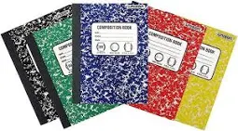

* 1 composition **wide-ruled** notebook
* Pencil case
* Crayons, colored pencils and/or markers

**Optional Student Supplies:**

* Eraser for dry erase board
* Scissors
* Glue sticks