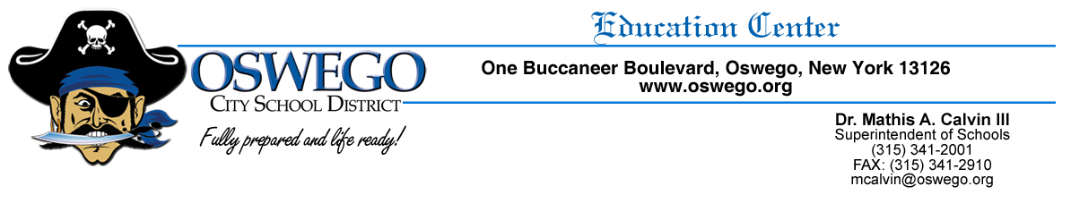
OSWEGO CITY SCHOOL DISTRICT OPT-OUT PHOTO RELEASE

The Oswego City School District likes to celebrate the achievements of our students and staff. Throughout the year, the Public Relations Department and district staff may take photographs of students and school activities. These photographs may appear in various District materials, including the District’s website (Oswego.org), newsletters, yearbooks, brochures, social media pages, district calendar, etc. We at times, may also publicize student work.

If you DO NOT want your child’s name/photo/work publicized for these purposes you are asked to inform your child’s principal, in writing. A simple, written, signed note stating: “Please do not photograph my child for use in publications and/or web, including your child’s name and grade level. You may either drop off the note in person or mail it to the school your child is attending.

If you have any questions regarding this Student Photograph practice, please feel free to contact either your child’s principal or the Superintendent’s Office.

